# IP Network Configuration

On OFFICE-PC1

Step 1: Open Control Panel

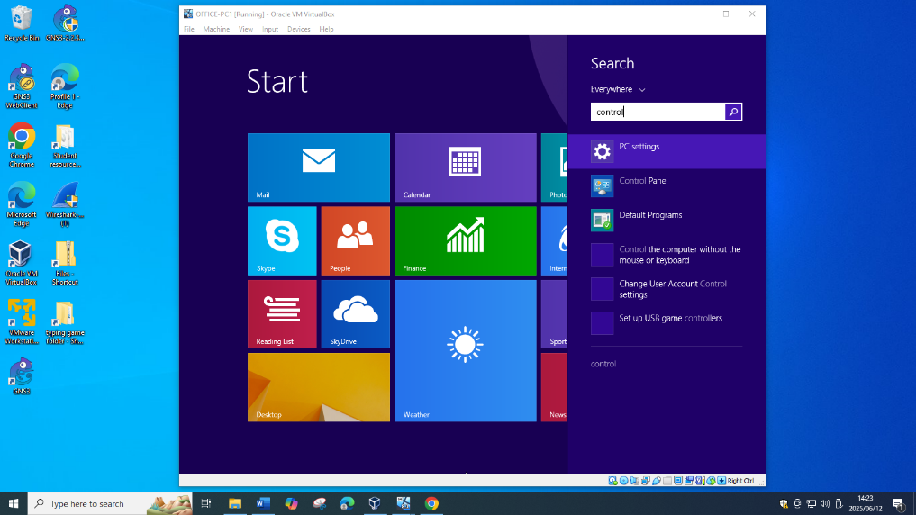

Step 2: Click Network and Internet

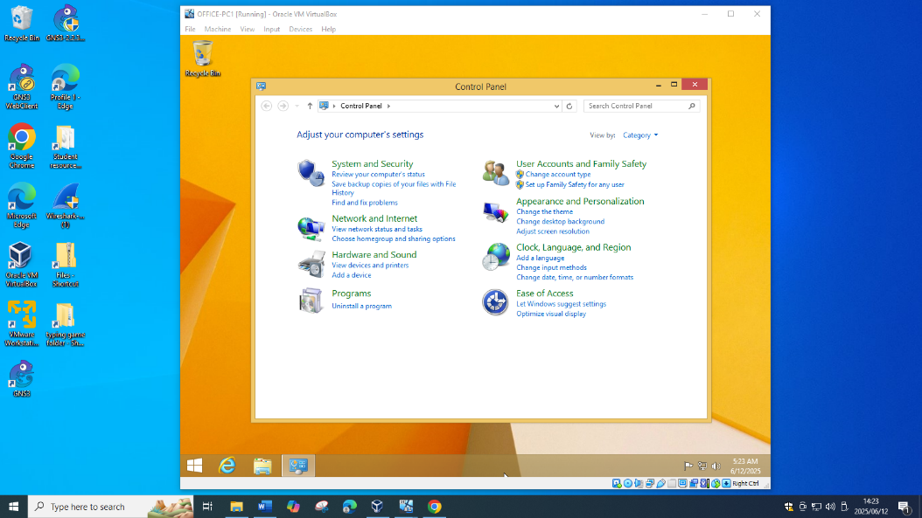

Step 3: Click Network and Sharing Center

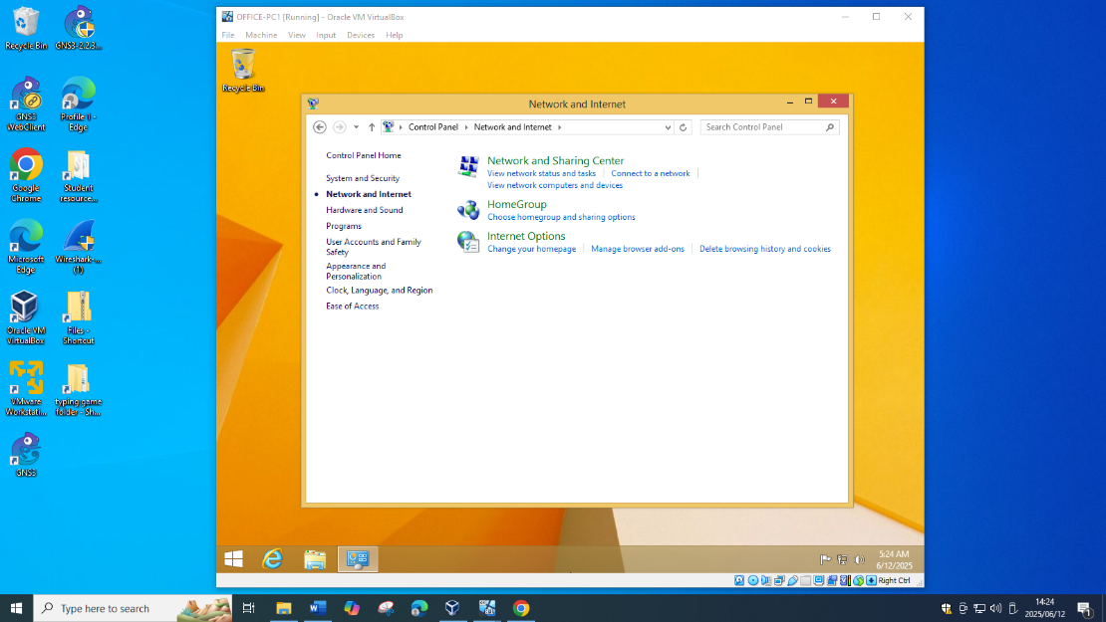

Step 4: Click Change Adapter settings

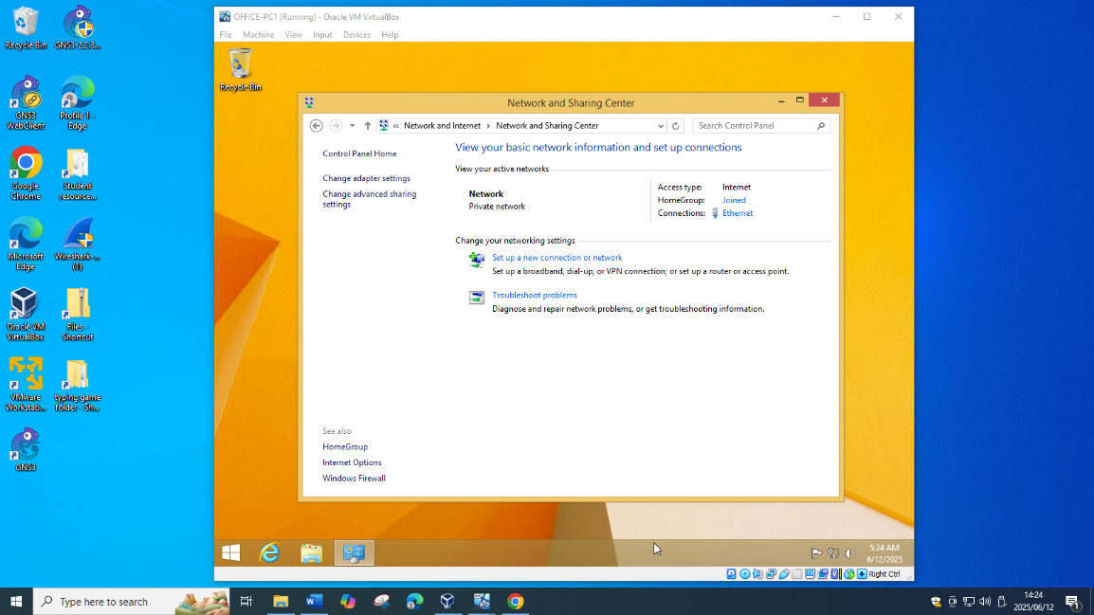

Step 5: Right Click Ethernet and click on Properties

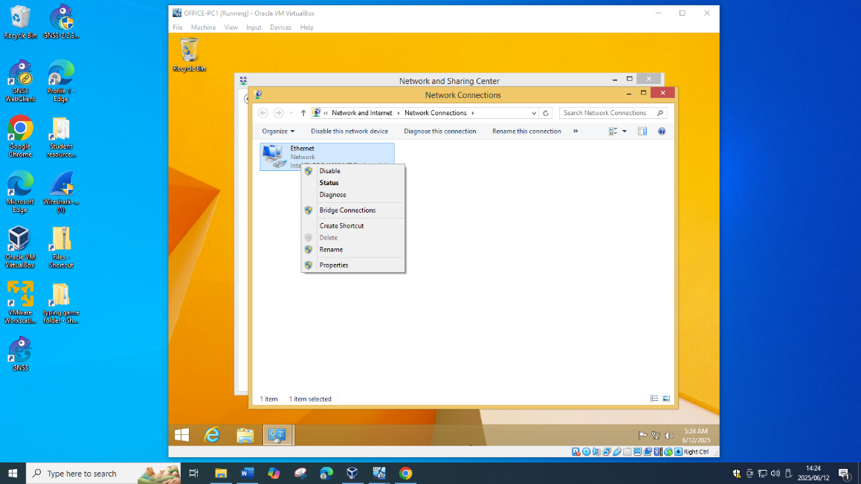

Step 6: Select Internet Protocol Version 4 and click Properties

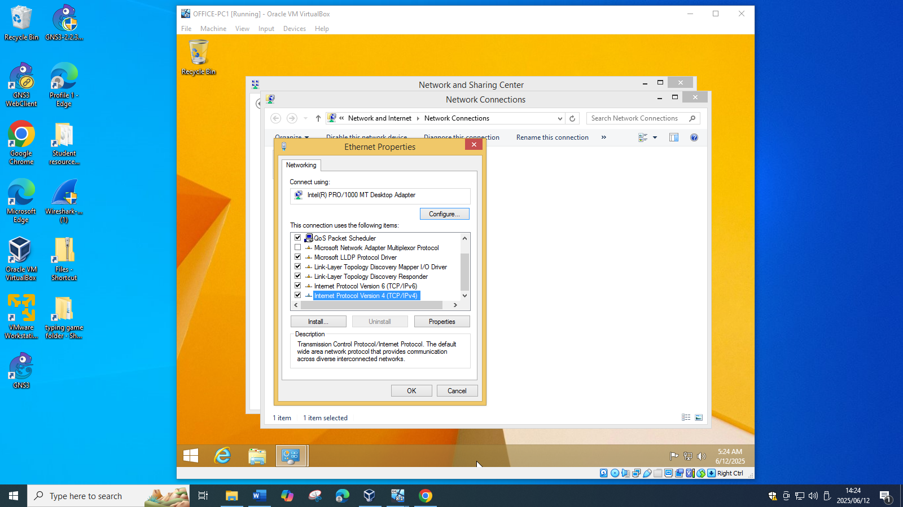

Step 7: Select Use the following IP address, set IP address: 192.168.1.65, Subnet mask 255.255.255.240, Gateway leave empty

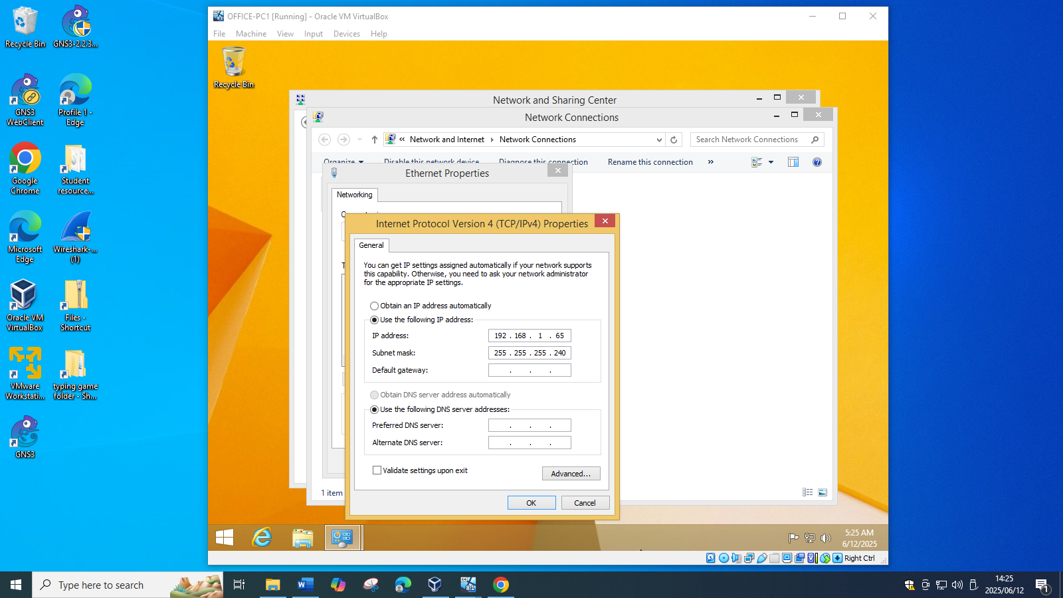

On OFFICE-PC2

Step 1: Open Control Panel

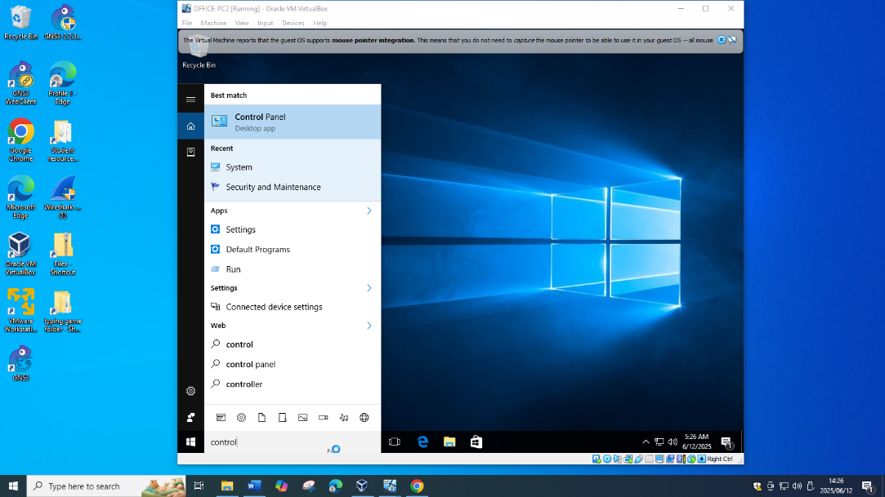

Step 2: Click Network and Internet

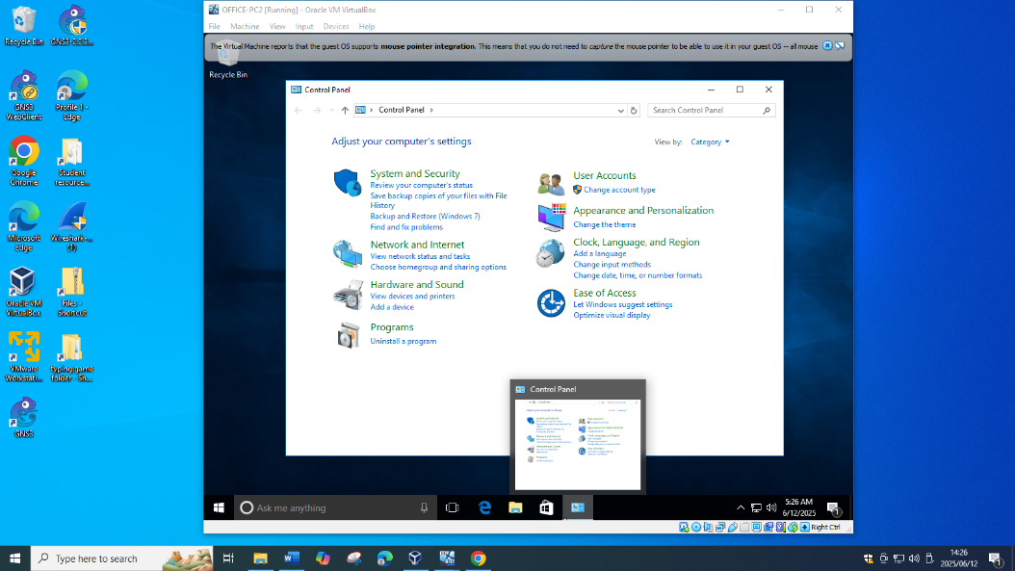

Step 3: Click Network and Sharing Center

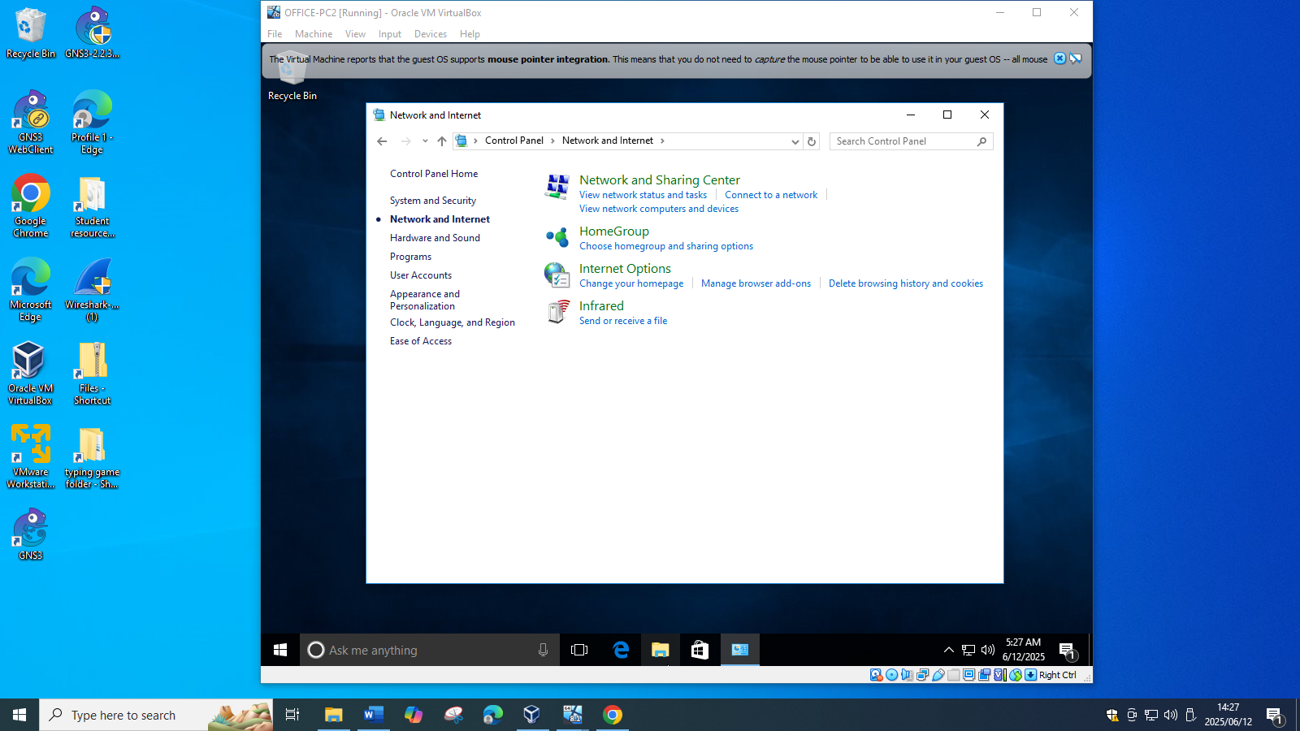

Step 4: Click Change Adapter settings

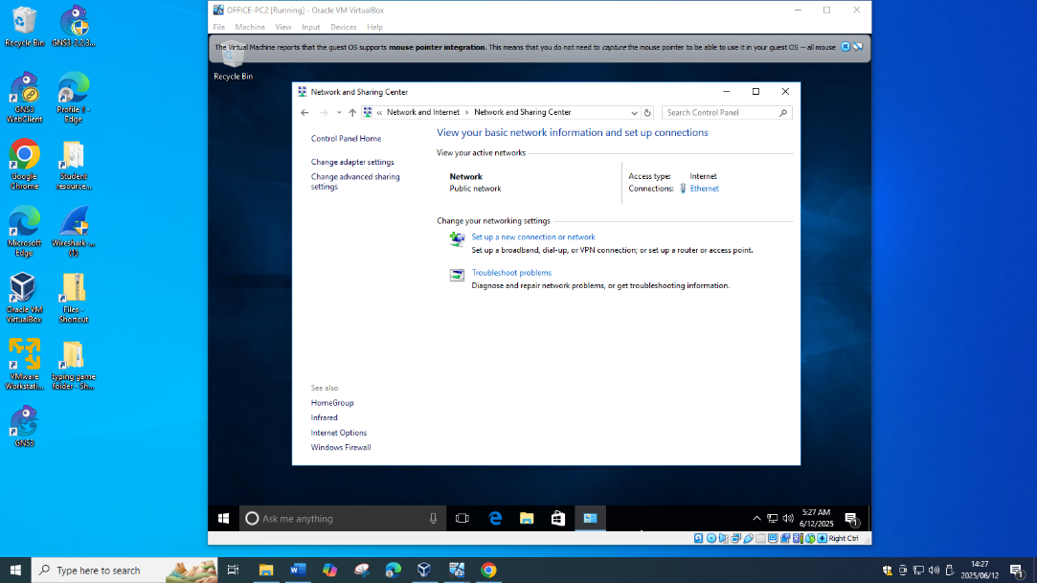

Step 5: Right Click Ethernet and click on Properties

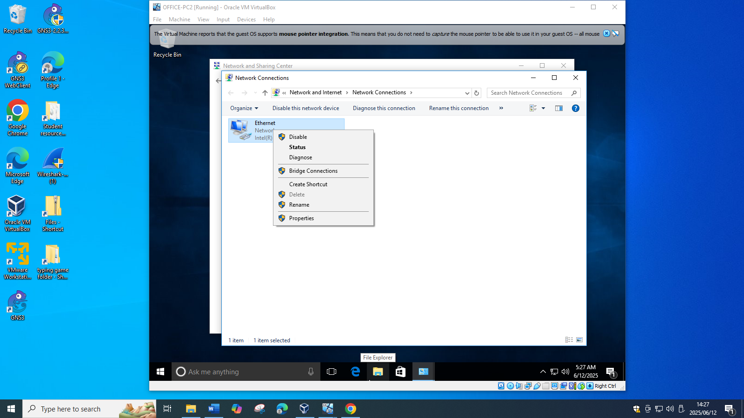

Step 6: Select Internet Protocol Version 4 and click Properties

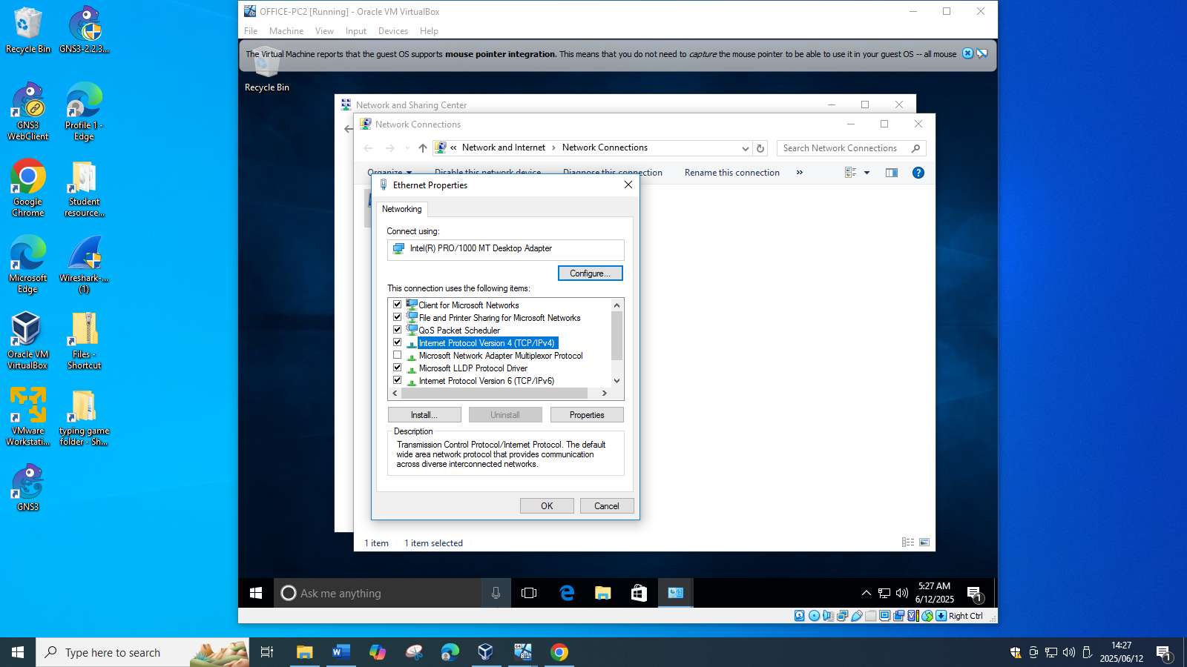

Step 7: Select Use the following IP address, set IP address: 192.168.1.65, Subnet mask 255.255.255.240, Gateway leave empty

